Irrigation system using DS3231 RTC Module

Circuit diagram:

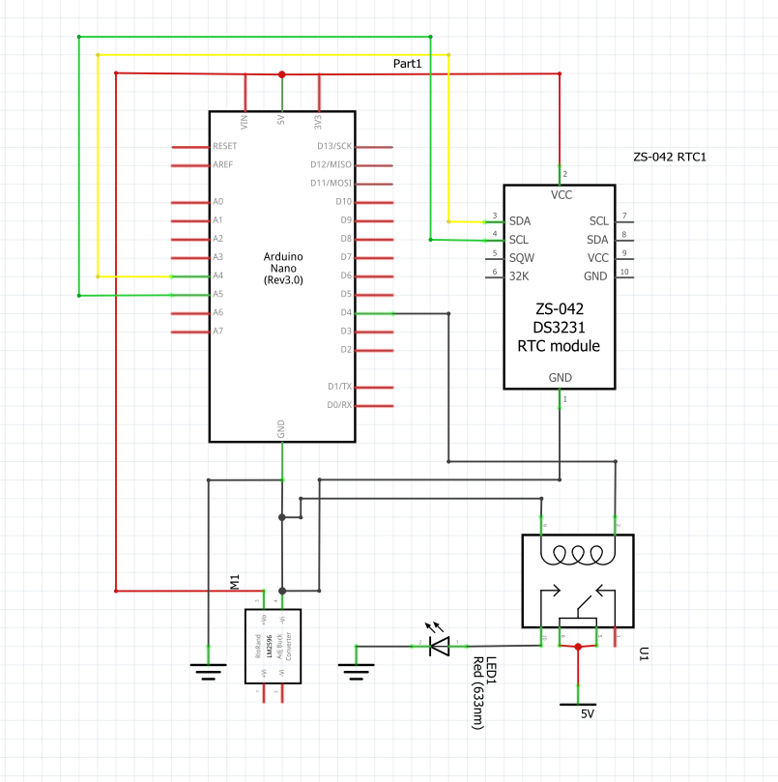

* Connections:

GND of RTC -- GND of Arduino

VCC of RTC -- 5V of Arduino

SDA of RTC -- A4 of Arduino

SCL of RTC -- A5 of Arduino

Relay I/P -- D4 of Arduino

* BUG Conveter O/P:

O/P of BUG (+ve) -- +5 of Arduino

O/P of BUG (-ve) -- GND of Arduino

* Procedure:

All required programs for this project I provided in this Folder. There are three programs I arranged by sequence, you just upload it sequence wise.

Arduino-DS3231-master before uploading any program at first install this library in your arduino IDE these are installing path(Sketch/Include library/ Add zip library).

Now are free to upload the programs …